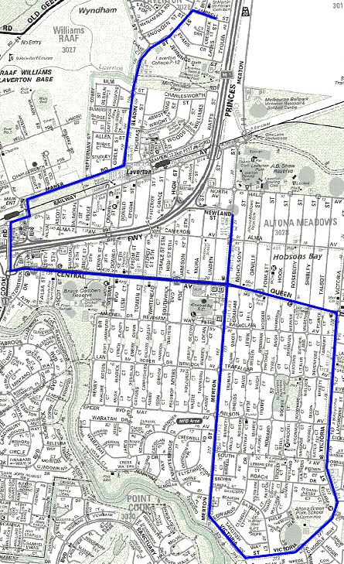
Laverton Secondary College
4542 - Altona Meadows – Laverton Secondary College & St Martin CPS
Start 8:00 Cnr Newland St and Merton St, Proceed up Merton ST over Queen St, Right Victoria St, Left Queen St, continue Central Ave, Right Point Cook Rd, Right Triholm Ave, Left Avaition Rd, Right Maher Rd, Left Bladin St, stop for Laverton Secondary College, Right Hillman St, Right Bellin St, Drop at St Martin CPS

